Title of the novel analysis
Name Surname
Institution, Department
City, Country, email@email.eus

Name Surname
Institution, Department
City, Country, email@email.eus

Minimum length 1000 and maximum length 2000 words without including references

Abstract: | 200-300 words that summarize the research (context, goal, results).  Do not include references
Key words: | LCA, Environmental Product Declaration, ... (7 maximum)

Graphical Abstract:

e.g.
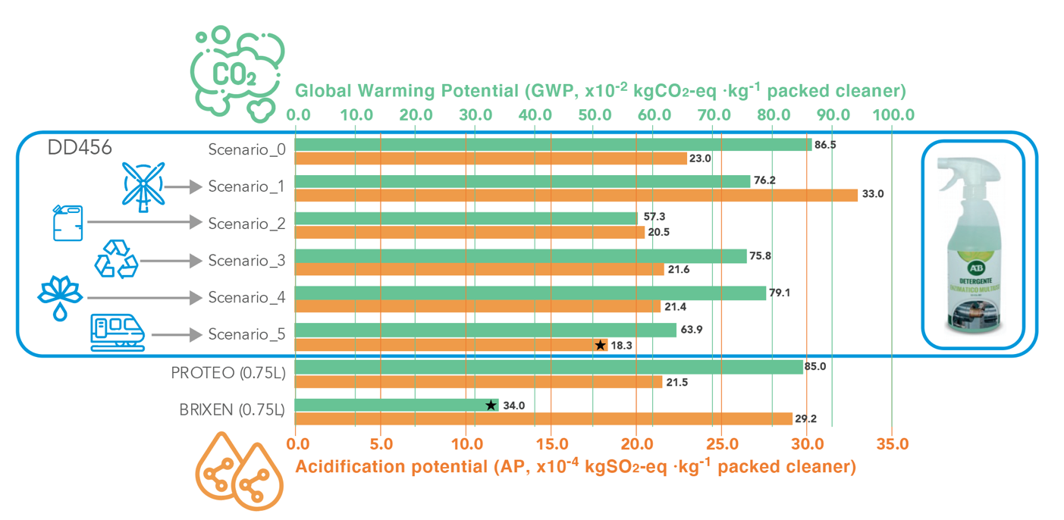

1. INTRODUCTION

Lorem ipsum dolor sit amet, consectetur adipiscing elit. Fusce feugiat orci dui, vitae bibendum felis tincidunt in. Integer sollicitudin nibh non magna condimentum, ac ullamcorper enim vestibulum. Morbi rutrum enim vel tempus sollicitudin. Sed tempor augue ut pharetra convallis. Donec in tellus lacinia, lacinia augue sed, auctor elit. Pellentesque quis vestibulum enim. Aliquam eget dolor non massa consequat hendrerit a quis libero. Donec egestas quam ac quam pharetra mattis. Integer ligula sapien, fermentum vel faucibus eu, finibus a nisl. Maecenas quis sem egestas, vulputate dui ac, hendrerit nunc. Donec mi mauris, accumsan id sollicitudin at, feugiat eget ante (Wiedmann and Lenzen, 2018).
2. METODOLOGY

Lorem ipsum dolor sit amet, consectetur adipiscing elit. Fusce feugiat orci dui, vitae bibendum felis tincidunt in. Integer sollicitudin nibh non magna condimentum, ac ullamcorper enim vestibulum. Morbi rutrum enim vel tempus sollicitudin. Sed tempor augue ut pharetra convallis (Arto et al., 2016).

3. RESULTS AND DISCUSION.

Lorem ipsum dolor sit amet, consectetur adipiscing elit. Fusce feugiat orci dui, vitae bibendum felis tincidunt in. Integer sollicitudin nibh non magna condimentum, ac ullamcorper enim vestibulum. Morbi rutrum enim vel tempus sollicitudin. Sed tempor augue ut pharetra convallis (Akizu-Gardoki et al., 2020).

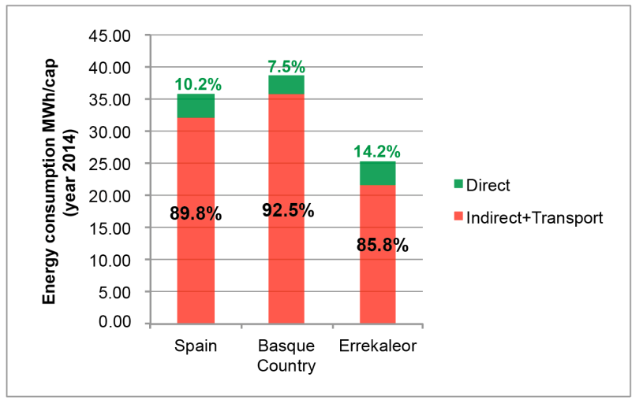
Figure 1. Description of the figure (under the figure).

Lorem ipsum dolor sit amet, consectetur adipiscing elit. Fusce feugiat orci dui, vitae bibendum felis tincidunt in. Integer sollicitudin nibh non magna condimentum, ac ullamcorper enim vestibulum. Morbi rutrum enim vel tempus sollicitudin. Sed tempor augue ut pharetra convallis. Donec in tellus lacinia, lacinia augue sed, auctor elit. Pellentesque quis vestibulum enim. Aliquam eget dolor non massa consequat hendrerit a quis libero. Donec egestas quam ac quam pharetra mattis. Integer ligula sapien, fermentum vel faucibus eu, finibus a nisl. Maecenas quis sem egestas, vulputate dui ac, hendrerit nunc. Donec mi mauris, accumsan id sollicitudin at, feugiat eget ante (Villamor et al., 2022), (Alejandre et al., 2022).

Table 1. Description of content (above the table).

4. CONCLUSIONS

Lorem ipsum dolor sit amet, consectetur adipiscing elit. Fusce feugiat orci dui, vitae bibendum felis tincidunt in. Integer sollicitudin nibh non magna condimentum, ac ullamcorper enim vestibulum. Morbi rutrum enim vel tempus sollicitudin. Sed tempor augue ut pharetra convallis. Donec in tellus lacinia, lacinia augue sed, auctor elit. Pellentesque quis vestibulum enim. Aliquam eget dolor non massa consequat hendrerit a quis libero. Donec egestas quam ac quam pharetra mattis. Integer ligula sapien, fermentum vel faucibus eu, finibus a nisl. Maecenas quis sem egestas, vulputate dui ac, hendrerit nunc. Donec mi mauris, accumsan id sollicitudin at, feugiat eget ante.

5. REFERENCES

Akizu-Gardoki, O., Wakiyama, T., Wiedmann, T., Bueno, G., Arto, I., Lenzen, M., Lopez-Guede, J.M., 2020. Hidden Energy Flow indicator to reflect the outsourced energy requirements of countries. J. Clean. Prod. 123827. https://doi.org/10.1016/j.jclepro.2020.123827
Alejandre, C., Akizu-Gardoki, O., Lizundia, E., 2022. Optimum operational lifespan of household appliances considering manufacturing and use stage improvements via life cycle assessment. Sustain. Prod. Consum. 32, 52–65. https://doi.org/10.1016/j.spc.2022.04.007
Arto, I., Capellán-Pérez, I., Lago, R., Bueno, G., Bermejo, R., 2016. The energy requirements of a developed world. Energy Sustain. Dev. 33, 1–13. https://doi.org/10.1016/j.esd.2016.04.001
Villamor, E., Akizu-Gardoki, O., Heinonen, J.T., Bueno, G., 2022. Global Multi-Regional Input-Output methodology reveals lower energy footprint in an alternative community project. Sustain. Prod. Consum. 34, 65–77. https://doi.org/10.1016/j.spc.2022.09.003
Wiedmann, T., Lenzen, M., 2018. Environmental and social footprints of international trade. Nat. Geosci. 11, 314–321. https://doi.org/10.1038/s41561-018-0113-9

Supplementary Material

In case that supplementary information is required especially the inventories of performed LCAs or GMRIO include them.

Table S.1: Description of the table.

